Asam Mahmood

Project 5

IONIC/FIREBASE

7/27/2016

***Project 5***

Project 5 was a really fun project I learned a lot. I was able to successfully create an ionic CRUD application with firebase. I created a whole new list taking application which was difficult throughout. I also added features and was able to update real-time the firebase database. I tested and debugged the project live using the simulators. I also watched many tutorial videos including material professor told us to cover. I was used a set toolset the professor gave us and it was really helpful. For version control I used git. For web development I used webstorm. I used command line interface for ionic. I used also a couple time ionic lab. I preferred the command line because of less lag. I chose the Android option. I successfully was able to emulate the application on android and Create, read, update, and delete objects from a real-time database on firebase. It was awesome watching the data change live as I was going. I chose android because I have a windows computer and I don’t have xcodebuild for windows. I was able to create Android Virtual device and installed the API I needed using the sdk manager. I setup the device through the sdk manager as well. I chose the API from the list of API on sdk manager that I needed. For firebase I was able to read and write to database real-time because I edit the rules and also I created the object in the application “var toDosRef=new Firebase (“https:// proj5amahmoo. firebaseio.com/ pro j5amahmoo");” .Like this above. I was able to add and delete and update the objects in Real-time. Which was really cool. I also found errors quicker using webstorm error check. I also learned ionic syntax which helped me out a lot and I found the framework pretty amazing. I was able to see ionic create an application on multiple platforms which was really fun while I was implementing it. I also had problems throughout. The emulator was not working at first and there was no documentation to fix it but I resolved correctly and have screenshot of the application working correctly. I was plagued by errors from ionic where it failed to serve but resolved it once I realized it was a network connection. I also had a big issue with firebase because objects were not being updated correctly but I ended up finding the solution by changing the rules of the database. I put everything side by side to see real-time updates as I was using the crud application. I learned how ionic lab emulator works. It’s basically a tool that emulates on android and iOS and web. It was helpful because it’s a quick and easy thing to use. When you need to test your project your able to watch live your changes as it demo’s and it is helpful heavily throughout development. A lot of IDE’s and emulators are bogged down and you can’t see your project live you constantly have to rebuild and rerun. But ionic makes it really simple for you. It basically stay opens and constantly updates. IONIC framework is pretty genius. As I was developing I saw this as the most important tool. A live emulator or testing device. I also had open the firebase console to constantly see the database being update as I was making changes to the application. The professor tutorials were helpful but didn’t cover issues that happened for me and didn’t show any way to resolve it. I had to find myself how to fix the problems and resolve them. It took a lot for my time from other things. I also had unexpected issues with installation of the tools and to make them work correctly. A lot of ionic issues is lacking documentation and it was hard for me to figure out issues. But I ultimately held it down and resolved it as I went. I was also constantly debugging and testing the project I found many issues solutions because of the live emulation that was happening with ionic lab. The emulator on ionic lab played a big role. I also used the command “ionic serve –l 8006” which run both emulators in your browser live and updates live as you’re developing which was pretty cool I thought. I discovered this command towards the end of the project and wished I found it earlier. I also took screen shots of the project live below through emulator. I used ionic emulator a lot and learned many things. This project was super helpful for me to understand how one framework can create three applications. It’s a shortcut and saves developer time in development. One can focus on the markup and let it build for everything else which is pretty cool. I also learned Angular JS more fluently through this project. I learned how model view controller are in sync. It’s an mvc architecture. I used w3schools as a sandbox area for my development to test small functionality that I had issued for my project. I learned a lot from this project and My list app was made from scratch. I research the ionic documentation and followed through with different example I created in m sandbox area during development. The command to multiple different things were helpful through command line. I learned a lot with what the framework can do with command line. But I created my own base line application from basically nothing. I read a lot of api information through firebase and also through the source code. I was given recommendation to read through source code to understand different api’s and implementation methods. That’s why I did my app the way it is. I also watch couple videos to get design insight and also researched different application implementation. I found my ui is smooth and a lot easier to use than other applications. I wanted to stress the CRUD implementation in a way where a user can test it out and see that I cemented the basic principle and can grasp concepts that are needed during development. I love this course I learned a lot and learned various ways of implementation which helped me. I also screenshotted the usage of the application in a emulator and through iconic lab. I also captured the database live updates. As I was using application.

Live view:

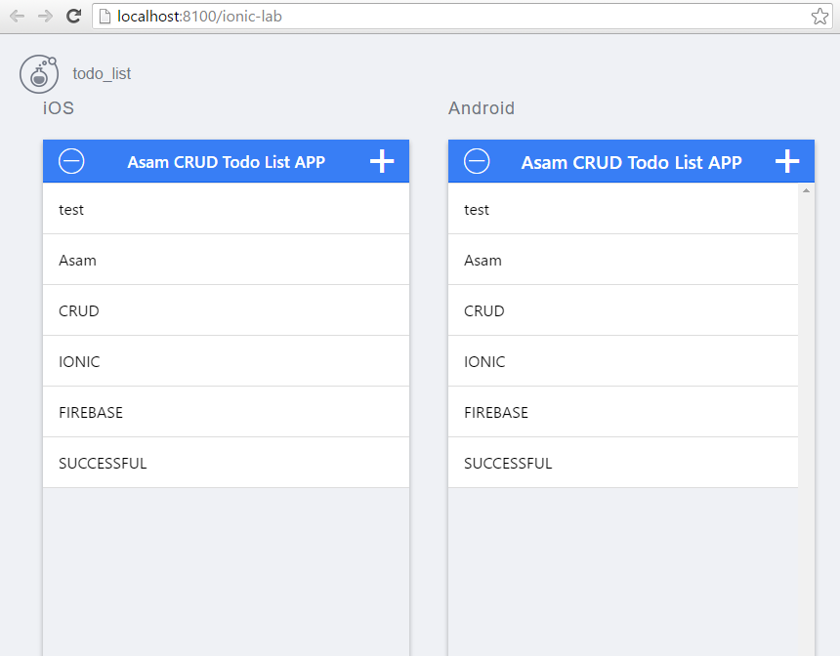

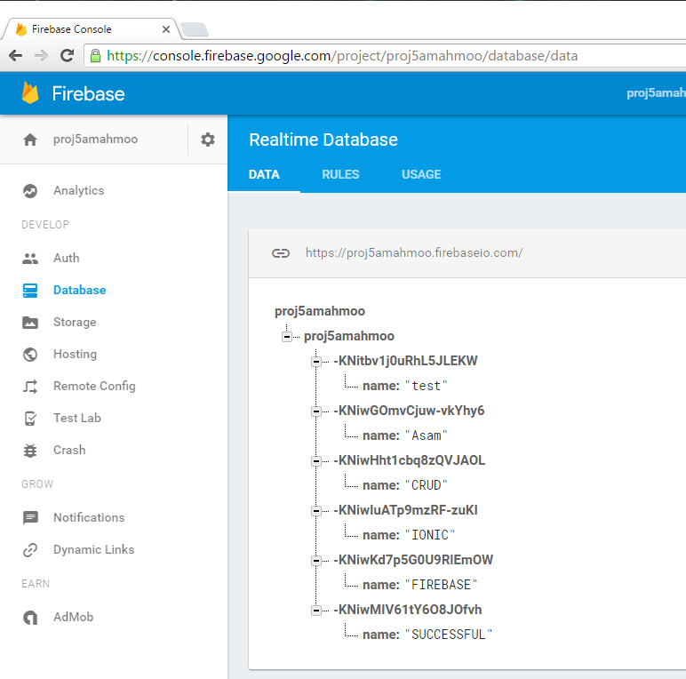

Android emulator :

